**YASH SARANG**

**D6AD**

**47**

**DLCOA / Experiment 11**

------------------------------------------------------------------------------------------------------------------------

**Aim:** To design an arithmetic logic unit Software Used: DLCOA virtual lab simulator

------------------------------------------------------------------------------------------------------------------------

**Theory:** In computing, an arithmetic logic unit (ALU) is a combinational digital circuit that performs arithmetic and bitwise operations on integer binary numbers. The inputs to an ALU are the data to be operated on, called operands, and a code indicating the operation to be performed; the ALU's output is the result of the performed operation. In many designs, the ALU also has status inputs or outputs, or both, which convey information about a previous operation or the current operation, respectively, between the ALU and external status registers.   
------------------------------------------------------------------------------------------------------------------------

**Design issues:** The circuit functionality of 1-bit is shown here, depending upon the control signal S1 and S0,

the circuit operates as:

S1 = 0, S0 = 0 : Output = A.B

S1 = 0, S0 = 1 : Output = A+B

S1 = 1, S0 = 0 : Output = ~A.B + A.~B

S1 = 1, S0 = 1 : Output = A add B

------------------------------------------------------------------------------------------------------------------------

**Objective:** Objective of 4-bit Arithmetic logic unit (with AND, OR, EXOR, ADD Operation):

1) Understanding behaviour of ALU from working module and the module designed by the student as part of the experiment.

2) Designing an ALU to give parameter. Conclusion: We have studied ALU and thereafter designed it in the virtual simulator and verified it.

------------------------------------------------------------------------------------------

**PROCEDURE:**

1. Select four 1-bit ALU from the “Other Components” menu. 5-bit displays and 11 bit switches from Input/Output and arrange them as shown below.

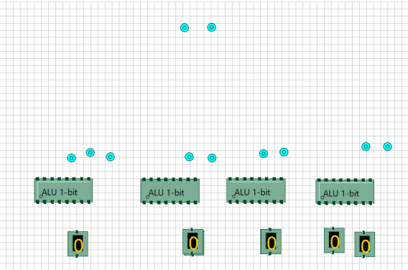

2. Connect all the components using the Connection tool as shown below.

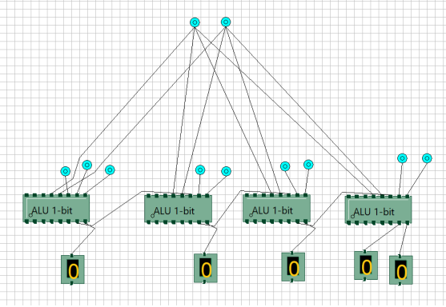

------------------------------------------------------------------------------------------

**OUTPUT:**



